DEPARTMENT OF COMPUTER SCIENCE & ENGINEERING
ABES Engineering College, Ghaziabad
SOFTWARE REQUIREMENTS
SPECIFICATION (SRS)
Project Title: Personalized Movie Recommendation System Using Collaborative Filtering
Standard Academic Compliance: IEEE Std 830-1998

SUBMITTED BY:  1. Pratyush Sahu (Roll No: 2400320100833)  Degree: Bachelor of Technology (B.Tech)  Academic Year: 2026 - 2027 | UNDER THE GUIDANCE OF:  Prof. / Dr. Ankit Mishra  Data Scientist  Department of Computer Science & Engg.  Status: 3rd Year Project Specification  Date of Submission: 01-10-2026

Document Revision & Approval History
Version | Date | Description / Major Changes | Prepared By | Reviewed By
0.1 | 15-Sep-2026 | Initial Draft & Scope Definition | Pratyush Sahu | Project Guide
1.0 | 30-Sep-2026 | Final 3rd Year Mid-Term SRS Baseline | Pratyush Sahu | HOD / Committee

Guidance Note: This Software Requirements Specification document conforms to the IEEE 830-1998 standard recommended practice. All sections are designed for 3rd-year university lab evaluation, project reviews, and system design baselines.

1. Introduction

1.1 Purpose
The purpose of this Software Requirements Specification (SRS) is to provide a complete, clear, and unambiguous definition of the functionality, external interfaces, performance targets, and constraints of the proposed system: 'Personalized Movie Recommendation System Using Collaborative Filtering'. The system uses Neural Collaborative Filtering (NCF) trained on the MovieLens dataset to predict user preferences and present ranked Top-K movie recommendations through a Streamlit interface. This document serves as the reference agreement between the student developer, project evaluators, and the academic supervisor during the 3rd-year engineering curriculum.

1.2 Scope of the System
The proposed application addresses the difficulty users face in discovering movies that match their individual interests. It does so by analyzing historical user–movie ratings and generating personalized recommendations in an end-to-end pipeline, from data ingestion to an interactive demonstration. Key boundary guidelines include:
- In-Scope Capabilities: MovieLens data ingestion, preprocessing, user/movie ID encoding, collaborative-filtering model development, preference prediction, Top-K recommendation generation, model evaluation, and Streamlit visualization.
- Out-of-Scope Boundaries: Movie streaming or purchasing, payment functionality, a mobile application, LLM/chatbot-based recommendations, production-scale authentication and infrastructure, and a separate backend service or database for the MVP.
- Expected Benefits: Personalized discovery of unseen movies, ranked Top-K recommendations, preference prediction from historical ratings, and an interactive Streamlit demonstration of the model.

1.3 Definitions, Acronyms, and Abbreviations
Category | Term / Acronym | Definition / Standard Context
Standard | SRS | Software Requirements Specification (IEEE Std 830-1998 format).
Standard | MVP | Minimum Viable Product: the first demonstrable version of the system.
Algorithm | CF | Collaborative Filtering: recommending items using the rating behaviour of many users.
Algorithm | NCF | Neural Collaborative Filtering: a neural-network model that learns user–item interactions from embeddings.
Algorithm | Embedding | Dense vector representation learned for each user and each movie.
Recommendation | Top-K | The K highest-ranked unseen movies by predicted preference for a user.
Recommendation | Cold Start | Situation where a user has too little rating history for reliable personalization.
Data | MovieLens | Public movie-rating dataset (ratings.csv, movies.csv) from GroupLens Research.
Evaluation | MAE / RMSE | Mean Absolute Error / Root Mean Squared Error of predicted ratings.
Evaluation | Precision@K, Recall@K, Hit Rate@K | Ranking-quality metrics computed over the Top-K list against held-out ratings.
Framework | Streamlit | Python framework used to build the interactive browser-based interface.
Framework | TensorFlow / Keras | Deep-learning library used to build and train the NCF model.

1.4 References
- IEEE Std 830-1998: IEEE Recommended Practice for Software Requirements Specifications.
- Software Engineering (10th Edition): Ian Sommerville, Pearson Education.
- Neural Collaborative Filtering: X. He, L. Liao, H. Zhang, L. Nie, X. Hu and T.-S. Chua, Proceedings of the 26th International Conference on World Wide Web (WWW), 2017.
- The MovieLens Datasets: History and Context: F. M. Harper and J. A. Konstan, ACM Transactions on Interactive Intelligent Systems, 2015.
- Official documentation: TensorFlow/Keras, Scikit-learn, Pandas, NumPy and Streamlit.

1.5 Document Overview
The remainder of this SRS is partitioned into the following sections. Section 2 outlines the product perspective, user classes, operating environment, and design constraints. Section 3 itemizes the functional requirements organized into logical software modules. Section 4 specifies external interfaces (user, hardware, software, and communication). Section 5 defines non-functional attributes (performance, security, reliability, portability, maintainability). Section 6 provides the standard academic analysis models: use case, data flow, entity-relationship, and sequence diagrams. Section 7 holds the academic sign-off.

2. Overall Description

2.1 Product Perspective
The project is a self-contained recommendation application made up of three parts: a Streamlit presentation layer, a Python-based recommendation and model pipeline, and CSV-based MovieLens data storage for the MVP. Neural Collaborative Filtering learns user and movie representations from historical ratings and uses them to generate personalized Top-K recommendations. The system does not depend on any external service at run time.
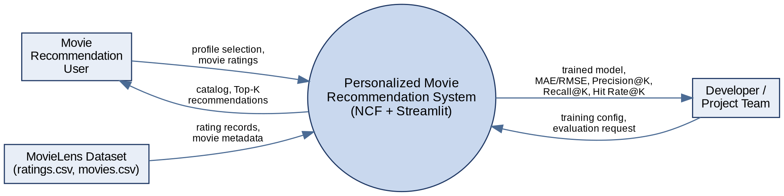
Figure 1: System context diagram (DFD Level 0)

2.2 User Classes and Characteristics
The software accommodates the following user personas:
User Role / Persona | Technical Proficiency | Core Responsibilities & Rights
Developer / Project Team | Intermediate / Advanced | Dataset preparation, model training, evaluation, recommendation pipeline integration, and maintenance.
Movie Recommendation User | Basic / Intermediate | Browse movies, select or create a simple profile, provide ratings, and receive personalized Top-K recommendations.
New User | Basic | Provide initial ratings and receive recommendations through the cold-start mechanism or popularity-based fallback.

2.3 Operating Environment
- Client Requirements: Modern web browser capable of running Streamlit; desktop display recommended.
- Server / Runtime Environment: Python 3.x with TensorFlow/Keras, Pandas, NumPy, Scikit-learn and Streamlit; development through Jupyter Notebook / VS Code.
- Data Storage Tier: CSV files containing MovieLens ratings and movie metadata; a database is not required for the MVP.

2.4 Design and Implementation Constraints
- Academic Budget Constraint: Use of open-source Python libraries, MovieLens data and Streamlit; no paid infrastructure is required for the MVP.
- Security / Scope Constraint: Complex authentication and production-scale security are out of scope for the MVP.
- Modularity Standards: Data preprocessing, model training, recommendation generation and Streamlit presentation are kept as separate logical components.

2.5 Assumptions and Dependencies
- Assumptions: MovieLens data is available, ratings are valid, and users can provide or select a profile and initial movie ratings.
- Dependencies: Python ecosystem, TensorFlow/Keras, Pandas, NumPy, Scikit-learn, Streamlit and the MovieLens dataset.

3. System Features and Functional Requirements
Requirements are categorized by functional subsystem modules with unique requirement identifiers (FR-x.x):

3.1 Module 1: User Profile and Rating Interaction
Req ID | Feature Description | Input / Validation Rule | Priority
FR-1.1 | User Profile Selection / Creation | User selects an existing profile or creates a simple one; the profile identifies the user for recommendation generation. | High
FR-1.2 | Initial User Rating Input | User rates selected movies; each rating must be a valid value on the MovieLens rating scale and becomes collaborative-filtering input. | High
FR-1.3 | Profile Interaction State | The system maintains the user's selected and rated movies for the duration of the recommendation session. | Medium

3.2 Module 2: Data Processing and NCF Recommendation Engine
Req ID | Feature Description | Input / Validation Rule | Priority
FR-2.1 | MovieLens Data Ingestion | Load ratings.csv and movies.csv containing userId, movieId, rating, timestamp, title and genres; reject malformed or missing records. | High
FR-2.2 | NCF Recommendation Engine | Encode user/movie IDs, learn embeddings, model neural interactions and predict user preference for a movie. | High
FR-2.3 | Recommendation Data Processing | Prepare and transform interaction data into training and test sets used for model training, evaluation and Top-K generation. | High
FR-2.4 | Trained Model Persistence | Save trained model weights and embeddings and load them at inference time so the application does not retrain on every run. | High

3.3 Module 3: Recommendation, Evaluation & Streamlit Interface
Req ID | Feature Description | Input / Validation Rule | Priority
FR-3.1 | Top-K Recommendation Display | Rank unseen movies by predicted preference and display the Top-K personalized recommendations. | High
FR-3.2 | Recommendation Evaluation | Evaluate prediction quality using MAE/RMSE and recommendation quality using Precision@K, Recall@K and Hit Rate@K. | High
FR-3.3 | Rated-Movie Filtering | Exclude movies the user has already rated from the personalized Top-K list. | High
FR-3.4 | Cold-Start Handling | For users with insufficient history, collect initial ratings or provide a popularity-based fallback list. | High
FR-3.5 | Movie Catalog Browsing | Display a browsable movie catalog with title and genres to support selection and rating. | Medium

4. External Interface Requirements

4.1 User Interfaces (UI)
The interface is implemented using Streamlit. It provides a simple movie catalog, user/profile selection, movie rating input, and a recommendation view that displays ranked Top-K movies. Previously rated movies are excluded from the personalized list. Forms give immediate visual feedback through success messages or inline error alerts. The planned screens are:
Screen | Purpose | Key Elements
1. Movie Catalog / User Selection | Browse movies and choose or create a profile. | Movie list with title and genres; profile selector.
2. Movie Rating Interface | Capture initial ratings from the user. | Rating input per movie; list of rated movies.
3. Personalized Top-K Recommendations | Show the ranked recommendation list. | Ranked movies with predicted preference; rated movies excluded.
4. Evaluation / Model Demonstration | Demonstrate model quality. | MAE, RMSE, Precision@K, Recall@K, Hit Rate@K.

4.2 Hardware Interfaces
- Standard Deployment: Keyboard, mouse, display (720p or higher) and a web browser for interacting with Streamlit.
- Embedded / IoT Interfaces: Not applicable to this project.

4.3 Software Interfaces
- Data Interface: Pandas reads the MovieLens CSV files for ratings and movie metadata.
- ML / UI Libraries: TensorFlow/Keras for the NCF model, Scikit-learn for data splitting and evaluation, and Streamlit for the interactive interface.

4.4 Communication Interfaces
- Application Interface: Streamlit provides the browser-based interface over HTTP/HTTPS; no separate REST backend is required for the MVP.
- Data Format: CSV for MovieLens datasets; in-memory Python/Pandas structures during processing.

5. Non-Functional Requirements (NFRs)
Attribute | Target Metric / Standard | Verification & Testing Method
5.1 Performance | Recommendation response is interactive for the demonstration dataset; Top-K generation completes within a few seconds. | Measure recommendation generation time during Streamlit testing.
5.2 Security | No sensitive personal data is required; complex authentication is outside MVP scope. | Review application inputs and verify no unnecessary sensitive data is stored.
5.3 Reliability | Stable end-to-end execution of data loading, model inference and recommendation display. | Run repeated end-to-end recommendation tests.
5.4 Portability | The Python/Streamlit application runs in the documented development environment and in supported modern browsers. | Execute the application in the project environment and test browser access.
5.5 Maintainability | Preprocessing, training, recommendation and UI code are separate modules so each can change independently. | Code review against the modular structure in Section 2.4.

6. System Design and Analysis Models
The following standard analysis models illustrate the static and dynamic behaviour of the application.

6.1 Use Case Diagram
The diagram maps the two actors, the Movie Recommendation User and the Developer / Project Team, to the functions they use.
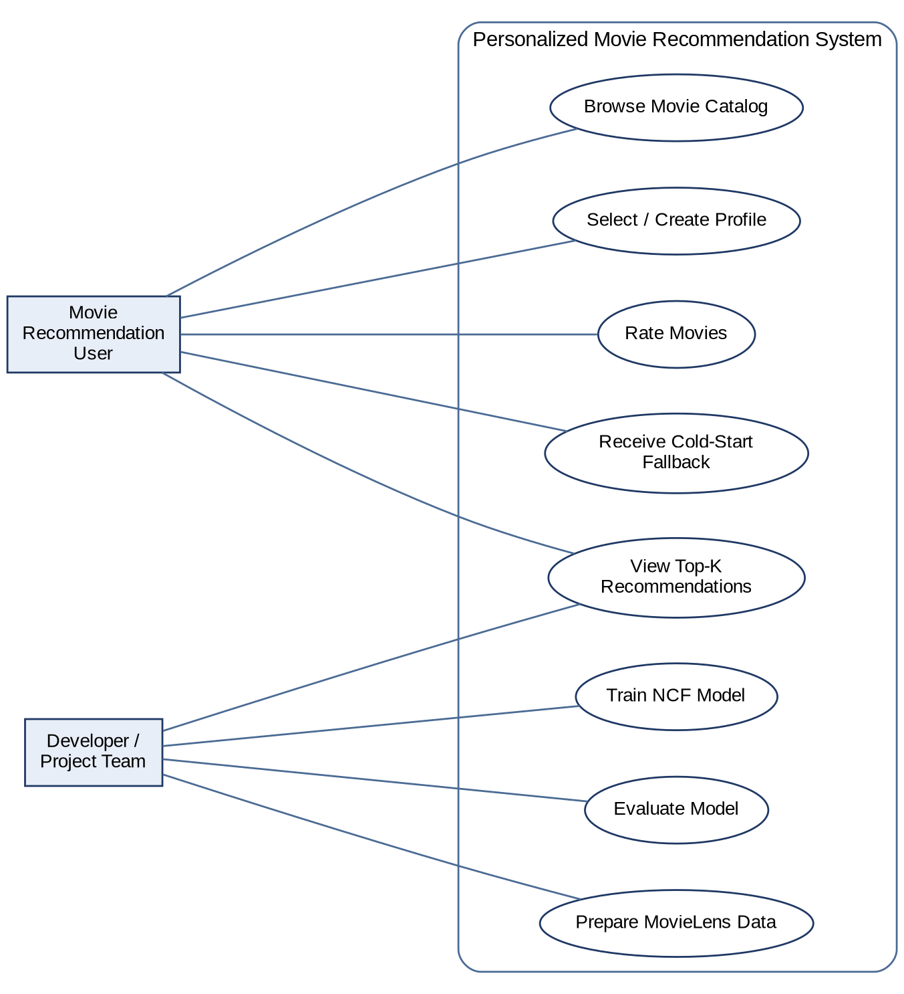
Figure 2: Use case diagram
Use Case | Actor | Description
Rate Movies | Movie Recommendation User | User selects movies and supplies ratings that become model input.
View Top-K Recommendations | User, Developer | System predicts preference for unseen movies, excludes rated ones and displays the ranked list.
Receive Cold-Start Fallback | New User | With insufficient history, the system asks for initial ratings or shows popular movies.
Train NCF Model | Developer / Project Team | Developer trains the model on prepared MovieLens data and saves weights and embeddings.
Evaluate Model | Developer / Project Team | Developer computes MAE/RMSE and Precision@K, Recall@K, Hit Rate@K on held-out data.

6.2 Data Flow Diagram (DFD)
Level 0 (context) is shown in Figure 1. Level 1 decomposes the system into five processes: ingestion and preprocessing, ID encoding and NCF training, profile and rating collection, prediction with filtering and Top-K ranking, and model evaluation.
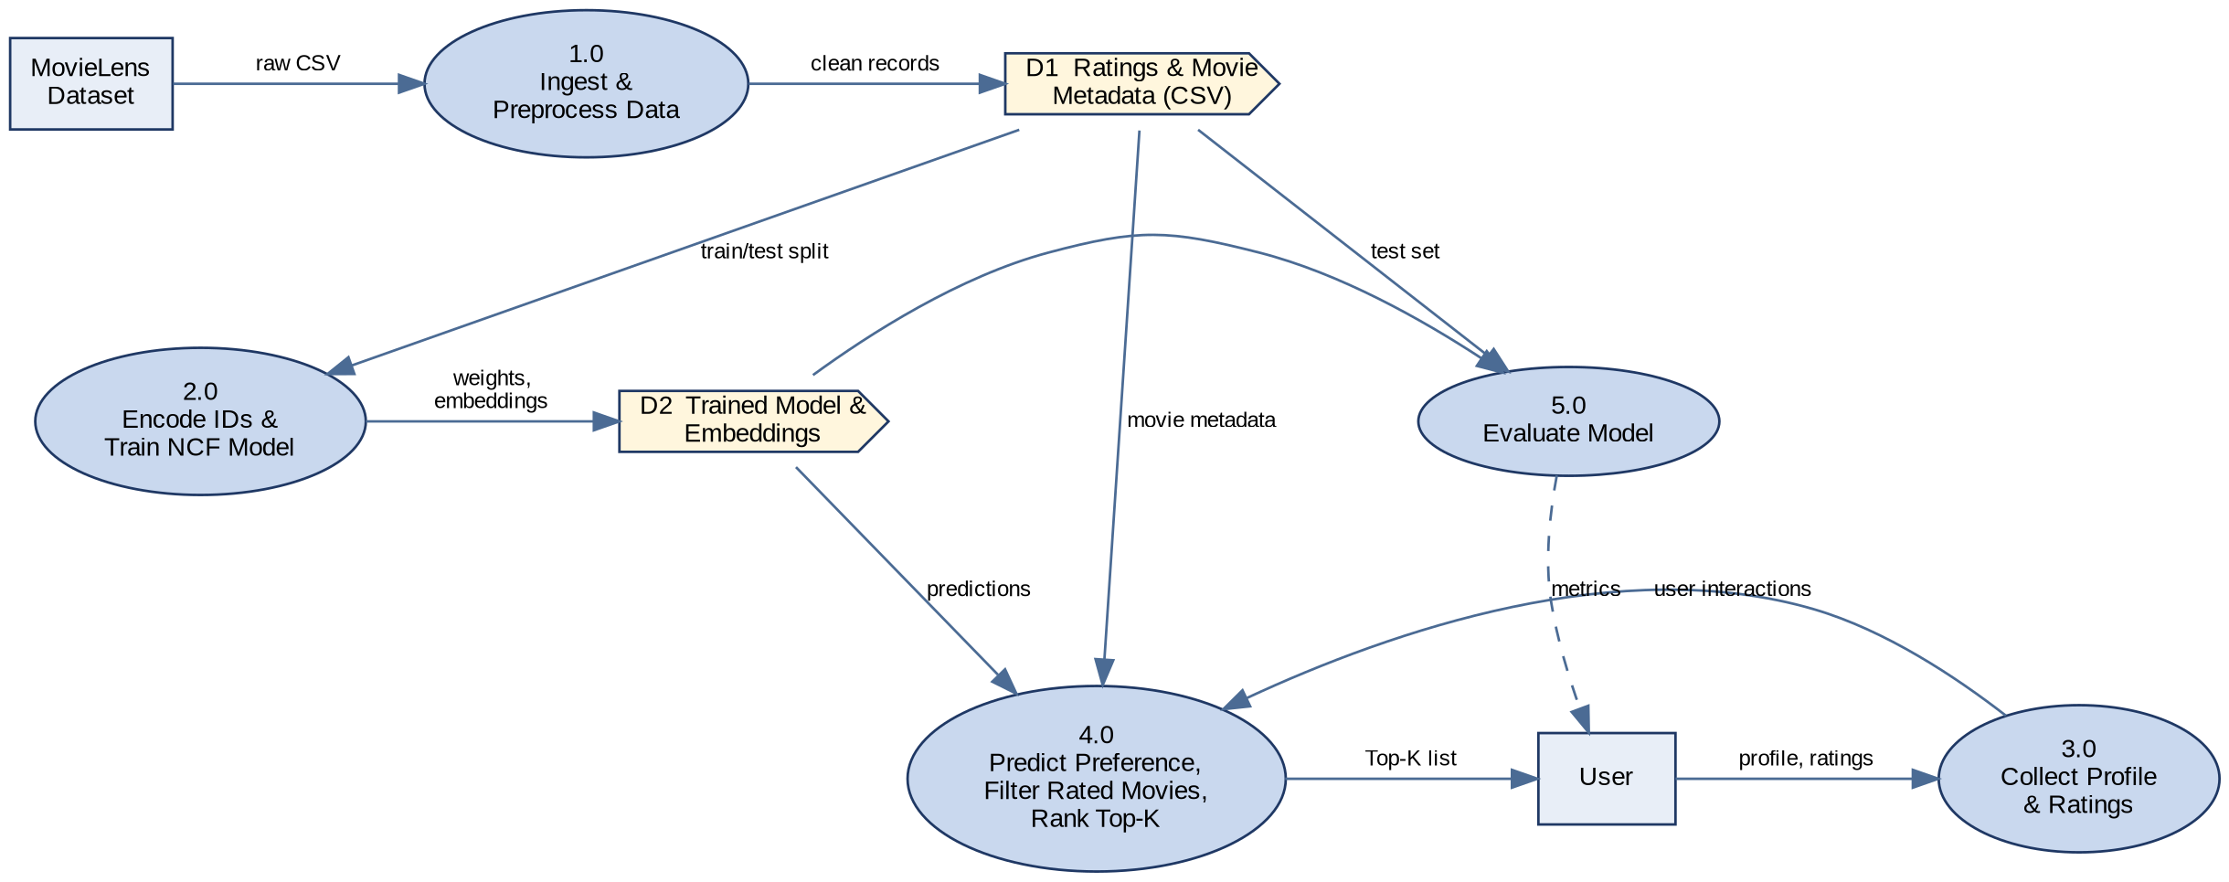
Figure 3: DFD Level 1

6.3 Entity-Relationship Diagram (ERD)
The data model has three entities derived from the MovieLens files. A user gives many ratings and a movie receives many ratings, so Rating is the associative entity keyed by (userId, movieId). The encoded user and movie indices are produced during preprocessing for use as embedding lookups. The schema is in third normal form: user and movie attributes are stored once, and rating facts are stored only in Rating.
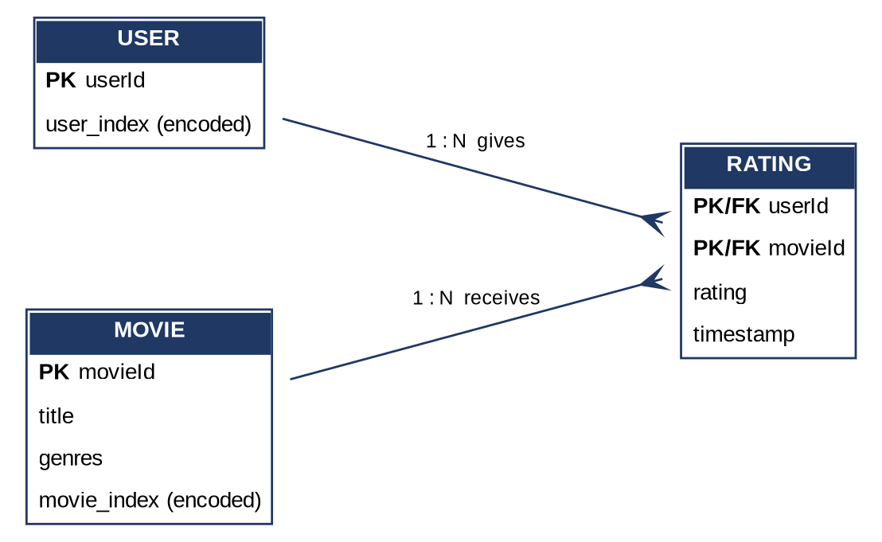
Figure 4: Entity-relationship diagram (crow's foot notation)

6.4 Sequence Diagram
The sequence shows the main scenario from profile and rating input through ID encoding, NCF inference, filtering and Top-K display. The alternate flow covers users with too little history.
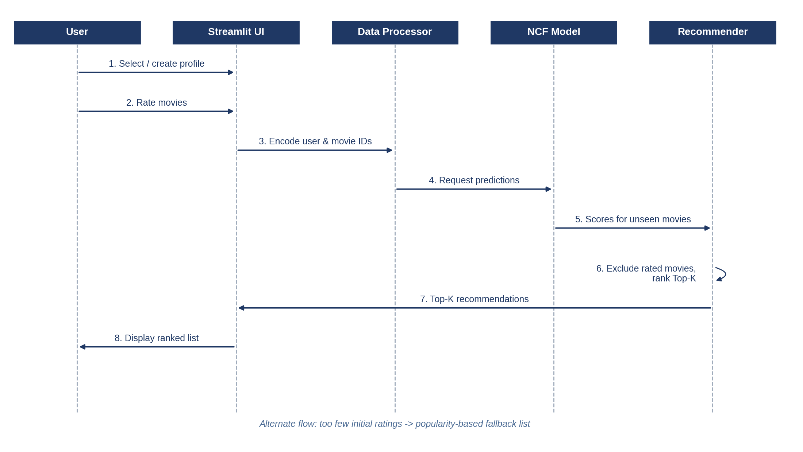
Figure 5: Sequence diagram for generating Top-K recommendations

7. Academic Review & Sign-Off
This Software Requirements Specification document has been submitted and reviewed by the academic supervisory panel:

Signature: __________________  Date: __________________ | Signature: __________________  Date: __________________ | Signature: __________________  Date: __________________

